**JUnit With Assertions:**

In test plan-right click-add-thread –thread group

Create a Java package in eclipseà create a Junit class and add Junit test annotationà create a junit method.

Add Junit 4 library in the java project.

After completing the script right click on project-export-java jar-next browse the folder.

The project should be saved in jmeter-lib-junit-in that .jar extension should be add within “ “ ,then save and finsh.

Close and restart jmeter.

ThreadGroupà addà junit request samplerà in the smapler select below details

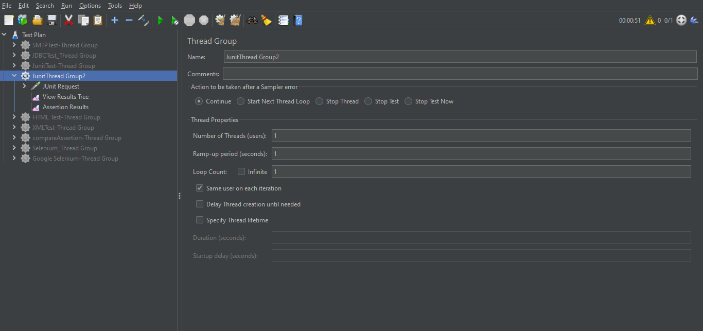

When we click on select annotation ,then automatically it takes the project .

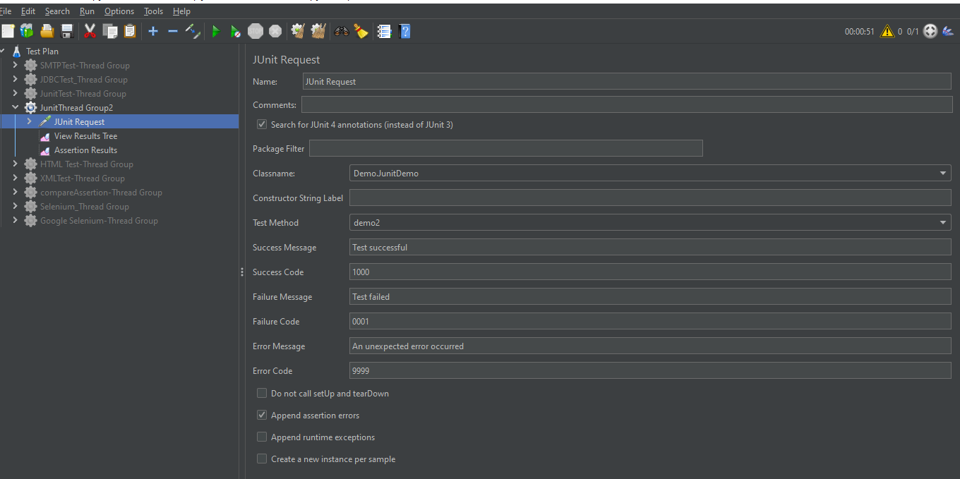

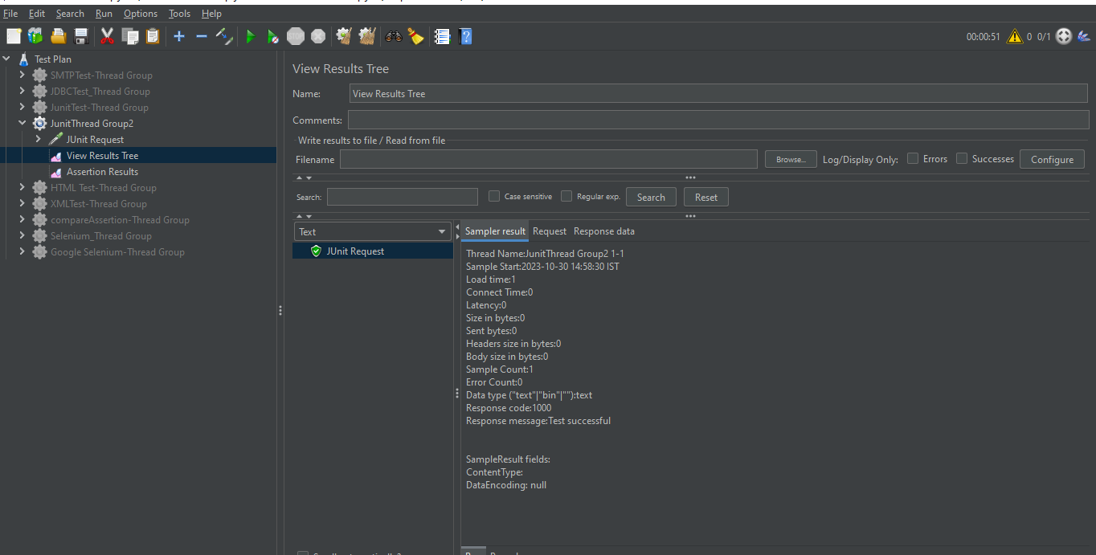

Junit assertion

